**Bahria University, Lahore Campus**

Department of Computer Sciences

Lab Journal 04

**(Spring 2023)**

|  |  |  |
| --- | --- | --- |
| Course: | **Computer Architecture & Organization Lab** |  |
| Course Code: | CEL 221 | Max Marks: 30 |
| Faculty’s Name: | Maryam Munawar | Lab Engineer: |

Name: _AFFAN AHMAD ___ Enroll No: _03-134221-003____

## Lab Tasks:

### Task1: 20 Minutes

Write programs to evaluate the following expressions. The user should enter the variables, and the program should print back an answer. Prompt the user for all variables in the expression, and print the results in a meaningful manner. The results should be as accurate as possible.

1. 5x + 3y +z

.data

a: .asciiz "Enter a number: "

b: .asciiz"enter b value: "

c: .asciiz"enter c value: "

result: .asciiz "the result of(5a+3b-c) is:"

.text

la $a0, a

li $v0, 4

syscall

li $v0,5

syscall

move $s0,$v0

la $a0, b

li $v0, 4

syscall

li $v0,5

syscall

move $s1,$v0

la $a0, c

li $v0, 4

syscall

li $v0,5

syscall

move $s3,$v0

mul $t1,$s0,5

mul $t2,$s1,3

add $t0,$t1 , $t2

add $t0,$t0,$s3

li $v0, 4

la $a0, result

syscall

li $v0, 1

move $a0, $t0

syscall

li $v0,10

syscall

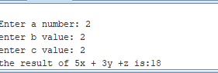

1. ((5x + 3y + z) / 2) * 3

.data

a: .asciiz "Enter a number: "

b: .asciiz"enter b value: "

c: .asciiz"enter c value: "

result: .asciiz "the result of(5a+3b-c) is:"

.text

la $a0, a

li $v0, 4

syscall

li $v0,5

syscall

move $s0,$v0

la $a0, b

li $v0, 4

syscall

li $v0,5

syscall

move $s1,$v0

la $a0, c

li $v0, 4

syscall

li $v0,5

syscall

move $s3,$v0

mul $t1,$s0,5

mul $t2,$s1,3

add $t0,$t1 , $t2

add $t0,$t0,$s3

div $t0,$t0,2

mul $t0,$t0,3

li $v0, 4

la $a0, result

syscall

li $v0, 1

move $a0, $t0

syscall

li $v0,10

syscall

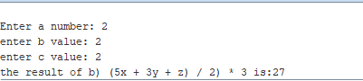

1. x3 + 2x2 + 3x + 4

.data

a: .asciiz "Enter x number: "

result: .asciiz "the result of(5a+3b-c) is:"

.text

la $a0, a

li $v0, 4

syscall

li $v0,5

syscall

move $s0,$v0

mul $t1,$s0,$s0

mul $t1,$t1,$s0

mul $t2,$s0,$s0

mul $t2,$t2,2

mul $t3,$s0,3

add $t0,$t1 , $t2

add $t0,$t0,$t3

add $t0,$t0,4

li $v0, 4

la $a0, result

syscall

li $v0, 1

move $a0, $t0

syscall

li $v0,10

syscall

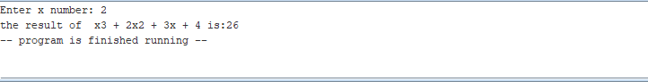

1. (4x / 3) * y

**.data**

**a: .asciiz "Enter x number: "**

**b:.asciiz"Enter y number: "**

1. **result: .asciiz "the result of** (4x / 3) * y **is:"**

**.text**

**la $a0, a**

**li $v0, 4**

**syscall**

**li $v0,5**

**syscall**

**move $s0,$v0**

**la $a0, b**

**li $v0, 4**

**syscall**

**li $v0,5**

**syscall**

**move $s1,$v0**

**mul $t1,$s0,4**

**div $t1,$t1,3**

**mul $t0,$t1,$s1**

**li $v0, 4**

**la $a0, result**

**syscall**

**li $v0, 1**

**move $a0, $t0**

**syscall**

**li $v0,10**

**syscall**

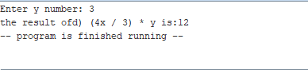

**Lab Grading Sheet :**

|  |  |  |  |
| --- | --- | --- | --- |
| **Task** | **Max Marks** | **Obtained Marks** | **Comments(*if any*)** |
| a. | 5 |  |  |
| b. | 5 |  |  |
| c. | 5 |  |  |
| d. | 5 |  |  |
| **Total** | **20** |  | **Signature** |

**Note : Attempt all tasks and get them checked by your Instructor**